**Milestone 2a:** User Research and Implications for Design

# Introduction:

## What is the problem?

Currently, many people struggle with being able to connect to other communities. This is due to the lack of interconnectivity between different communities. This lack of interconnectivity is created when people become too comfortable with the people and places around them and they aren’t able to interact with people outside that bubble. This leads to people feeling a sense of isolation and disconnection from people outside of their inner circle or community causing things such as mental health issues and communities feeling misrepresented.

During the COVID-19 crisis, there was a push towards work-from-home and staying at home in order to decrease activity between people. As the COVID-19 crisis started to decrease, people started to go out more, however, we saw a lot of the habits that formed during those times remained. As stated in the snippet from the “Journal of Psychiatry & Neuroscience”, “Given the importance of social interactions for humans, it is not surprising that most psychiatric disorders involve some disruption of normal social behavior, and that in several disorders abnormal social functioning is one of the central symptoms” (391 Young). This describes the importance of social interaction and how the lack of social interaction can lead to psychiatric disorders and abnormal functioning. We see in today’s society that it can become normal for one to not have much social interaction as things like online meet-ups and staying home have become more mainstream. This leads to people feeling comfortable around those in close proximity and discomfort around those outside that bubble. As social interaction declines, we see a lack of interconnectivity between people as they are more prone to be in isolation in today’s times.

This lack of interconnectivity causes communication and activity between different communities to be hard to achieve. As people become more comfortable only with people in their bubble it starts to lead to many problems including an increased disconnect between communities. As the disconnect increases, things such as misrepresentation of a community or mental health issues start to occur more frequently to people in different communities. Through our research, we see that many people share the opinion that social interaction is important and it leads to building different relationships and connections between a diverse set of people. All of our users in our interviews had connected communities to the way they lived. We see through this idea that social interaction can be a fundamental building block of different communities. Through our research, we see there is a lack of a platform that is able to connect these different communities who are becoming more and more comfortable living in a bubble with a lack of interconnectivity and that is the problem we want to tackle.

Work Cited

Young, Simon. “The Neurobiology of Human Social Behavior: an important but neglected topic”.

Journal of Psychiatry & Neuroscience, Vol. 33, 2008, pg 391.

## Why is the problem a problem?

The issue of people living in isolated bubbles can have a few negative impacts on individuals and society as a whole. When people live in a community or neighborhood where there is little communication or interaction with other communities, it can lead to a lack of understanding and empathy for people who are different from themselves. This can lead to stereotypes, prejudice, and discrimination.

In addition, when a neighborhood is misrepresented, it can lead to misunderstandings and misperceptions about the people who live there. For example, the Tenderloin is notorious for being a dangerous neighborhood with dangerous people. This can perpetuate negative stereotypes and reinforce prejudices. It can also make it more difficult for individuals who live in that neighborhood to access resources and opportunities that are available in other parts of the city or region.

This issue can also have negative effects on mental health, as living in an isolated bubble can lead to feelings of loneliness, isolation, and disconnection from society. Humans are social creatures by nature and they need community and a sense of connectivity, any form of isolation can have a negative impact on individuals.

## What is our secret sauce?

Our solution will bridge the gap between San Francisco’s diverse set of neighborhoods and communities. This will not only involve San Francisco residents but also people outside of the city. Our idea will facilitate socialization and discourage isolation among our users as it will help them find accurate information about certain neighborhoods, gain the perspectives of other users, and build connections. The group of users we’re targeting are those that live inside and outside of San Francisco and have an interest in visiting the city.

We’ve conducted a total of 6 semi-structured interviews with members of our target users; where we asked them about their experience and relationship with San Francisco, insights on researching neighborhoods, perspectives on investing in property in the city, and interactions and sense of identity they have in their own communities. From our interview responses, we found that people are reliable sources of information when it comes to learning about a certain place. We’ve also found that San Francisco is a genuinely attractive city as it accommodates a diverse group of communities and cultures. People typically travel to and want to know more about parks, monuments, restaurants, and bars. Regarding community, we’ve learned that the building of relationships and connections requires support and frequent socialization. In addition to this, we noticed that people typically stick to areas they are familiar with. But when it comes to stepping out of that area of familiarity, people experience a level of uncertainty with unfamiliar areas. From these research findings, we discovered that connecting and reaching out to others helps people step out of their physical bubble, whether it’s their house, neighborhood, or city. Having a connection to someone in an unfamiliar place makes a person feel more welcomed in an unfamiliar place.

## Why should the readers care?

### What is the expected outcome?

* Easier access to local data: More accurate information about certain communities because it's coming from credible resources: locals
* People feel more comfortable going out of their bubbles and exploring areas outside their neighborhoods.
* Learning different perspectives: More interconnectivity between communities
* Accurate resident reviews of districts:
  + People Inside their community will feel closer to their own communities
  + People Outside the community have better/more accurate understandings of different communities

### Are there any yet unforeseen consequences from the design?

* The spreading of false and opinionated information through reviews
* Excessive highlighting of the negative aspects of an area rather than positive
  + Confirmation of bad/unsafe areas?
  + Facilitating degradation of certain areas
* People don’t participate and become a less reliable source of information
* Typical Social Media Issues: Filtering out spam, and online harassment

### What is the impact going to be?

* Definition of categorization of bad and good areas by determining where people should visit.
* A better resource for those who spread information by word of mouth
* People feel they have more freedom to travel, are more aware of their surroundings, and feel more comfortable in an unfamiliar area
* Or no impact at all (Dead App)

# Research Methods:

The research methods that we used are informal conversation and semi-structured interviews. The reason why we used those methods is that we wanted to acquire the perspectives of our target users, people who are involved in or interested in the communities of San Francisco. A total of 6 people participated in our interviews; some of them were interviewed via Zoom, others in person, and one person was interviewed by phone call. We distributed a demographic survey to our participants with a Google form link. The survey helped us acquire factual background information on our respondents. This helped us understand the diversity of our respondents regarding race, gender, and whether they live inside or outside of San Francisco.

All five team members were involved in the analysis process. We came up with high-level themes by using the data we got from the interviews. Our process involved affinity mapping to identify common user behavior, sentiments, and patterns. This was achieved by collecting and grouping data to identify high-level themes. Doing so helped us acquire background information, better understand our target audience, and identify user needs and certain pain points regarding connecting with others in SF.

# Findings:

## Theme 1: SF Resources and Research

**People and connections are a common source of information to understand a certain area and find places to go.**

Locals/residents are the experts on the areas they live in or frequent

* *Knows the good and bad areas of SF by heart since he lived there so long: Went to Fisherman’s Wharf, arcade, and Pier 39 often*
* *Finds the best way to reach out to other people in the community is to try to go out and meet people*

Non-residents use locals/residents as a resource to understand a certain area.

* *“I will definitely research the area before I move. Usually, I ask people around, my family, friends, or their friends if they live there and their experience there, and seek advice”*
* *Believes it is important to understand a community by visiting it first*

The Tenderloin is a notorious area to avoid in SF.

* *Avoids the Tenderloin, but has really good food! There is a good Thai restaurant and a Banh Mi restaurant.*
* *Sometimes he can’t walk to the tenderloin with confidence; prefer to drive at the tenderloin*

People in SF are nice and happy to be a resource for information

* *“I met a lot of good people at SFState!”*
* *Neighbors help each other and bring packages from the lobby to neighbors’ doors to prevent them from being stolen.*

People research unfamiliar places online before visiting them

* *Looks up reviews online before moving*
* *Watches the news to confirm if downtown is safe*

**When researching a certain place, common topics include schools, public activity, safety, and culture.**

If moving into SF: safety distance from work and essentials, schools, and neighborhood activity/culture.

* *Different priorities when moving to the bay:*
  + *close to work*
  + *safe area*
  + *access to essentials*
* *Decides location on willingness to live there, closeness to amenities, and how good schools are near the location*

Schools are a common reason for relocation

* *Ended up moving to SF for a job and deciding to go back to school*
* *Came to the US and SF to pursue an education in design*
* *“Since I am a teacher, it’s important for me to learn about the different people and students within a certain area before moving there”*

People want to be aware of their neighborhood activities.

* *Active in programs like Neighborhood Watch*
* *If I were in SF and looking for a community I would:*
  + *Say “Hi” to people in the building*
  + *Look into a Nextdoor or Facebook group near her*
  + *Stick with her current community*
  + *Look for events and try meetups*

If visiting SF: safety, restaurants/bars, public activities, SF attractions

* *He went to SF with his girlfriend and his friends a lot of times and usually, they go together for bar hopping*
* *Visits the following places often:*
  + *Japantown*
  + *Pacific Heights*
  + *Pier 39 (beach)*
  + *Golden Gate park*
  + *Westfield*
  + *Stonestown*
  + *Patagonia (big Patagonia fan)*

**There are various tools for learning or researching about a specific place.**

Nextdoor doesn’t seem to be enough and has a number of downsides or user complaints.

* *I have tried to sign up for NextDoor before, but it requires your physical address, and I did not feel too safe. The location was too specific.*
* *Has the NextDoor app but finds it annoying.*
  + *Turned off notifications*
  + *A lot of spam/scams*
  + *Checks Nextdoor occasionally*
  + *Feels that Nextdoor contains negative posts*

Google Maps is a reliable and helpful resource.

* *Likes how Google Maps reroutes the user due to traffic conditions. Finding being notified of this information ahead of time and being offered solutions to avoid it really helpful.*
* *If I am moving to a big apartment complex, usually Google Maps has reviewed so I will read reviews.*

## Theme 2: SF Safety

**Safety is a factor people consider when searching for places to live or travel to in SF.**

* *I use the website, Megan's Law, to see if the area that I am moving is safe or not*
* *“As long as you avoid some areas, it’s pretty good. Good food, good transportation, beautiful city.”*

**Those familiar with SF know certain lifestyle habits to stay safe in the city.**

* *SF late at night is walkable for him mostly in neighborhood areas*
* *Stolen packages are a concern for her and she has to be careful with her mail and packages.*

**Non-residents feel uncertain/unsafe in SF.**

* *“[When I first came to San Francisco,] I felt that San Francisco was very sketchy and I didn’t like it—it felt dirty.”*
* *Visited Downtown SF a bit, but found it inconvenient with limited parking, druggies, and a bad rep from the news*

## Theme 3: SF Culture

**SF accommodates a diverse group of cultures and communities.**

An area’s culture is dictated by the people that occupy it.

* *Would rather have the people moving in incorporate the existing culture of the area with the new infrastructure*
* *They (she and her boyfriend) have a hard time becoming friends with Americans as people who come from other countries.*

**It’s expensive to live in SF.**

* *“There is a 20% deficit in housing supply. The number of jobs is significantly higher than the number of housing units in SF.”*
* *Agrees that gentrification is also a huge factor in the movement of home/housing price increases*

**SF attractions range from parks, tourist attractions, restaurants, and bars.**

*Bars and restaurants are common reasons to visit SF.*

* *Activities vary - usually nature-related things Golden gate park, checking out the bridge and bay*

## Theme 4: SF Communities

**Support from others is essential for maintaining close relationships with community members.**

It’s challenging to build or become a part of a community.

* *Finding a community can be inconvenient in this day and age.*
* *Community building requires constant interaction with community members.*
* *Community building is not a top priority.*
* *Geographic locations and origins are barriers to community building*

Communities don’t have to be location-based.

* *Reddit is a common online tool for building non-location-based communities.*

People belong to multiple communities.

* *Part of the community within LinkedIn (coworkers)*
* *Community open mic night at a local coffee shop*

Socializing and communities are essential to living.

* *Humans are social creatures, the more people we can rely on, the happier we can be*
* *Well-rounded life that is stable - multiple types of communities around you*

It’s easier to build a community if you share something in common.

* *Feels the most connected to a community when she is with her friends that are from China (those of similar backgrounds).*
* *Feels that he is older than the majority of the population around the school and just wants to finish school and then move out of there*

Community building stems from personal connections.

* *Her boyfriend, who lived in San Francisco, took her to the nicer parts of San Francisco and improved the way she saw the city.*
* *‘It depends on if they are my friends and I know them on a personal level.”*

# Discussion or Implications for Design:

## Solution Key Ideas & Possible Features

1. **Connect different communities together, incorporating inter-connectivity**
   1. Event Page: post and view events for different communities to come together
   2. Find/explore communities page and enable people to join them
2. **Provide accurate and accessible information about the identity of SF communities**
   1. Profile Page: for individual users/members and profile pages for communities
   2. Showing trending events, activities, and places within the community
3. **Allow users to engage with members of their own communities and other communities**
   1. Messaging system: community forum and direct messaging
4. **Highlight/showcase the positive and attractive aspects of a certain community**
   1. About me page (for a specific community): highlights all the best things about the region from different community members.
   2. Highlights page: shows what’s trending (activities, restaurants, events, parks/monuments) in a certain community. People can upvote and downvote.

## Sketches & Storyboards

Sketches that implement the key ideas listed above.

### Storyboard Design 1

Artist: William

Storyboard type: Close-up

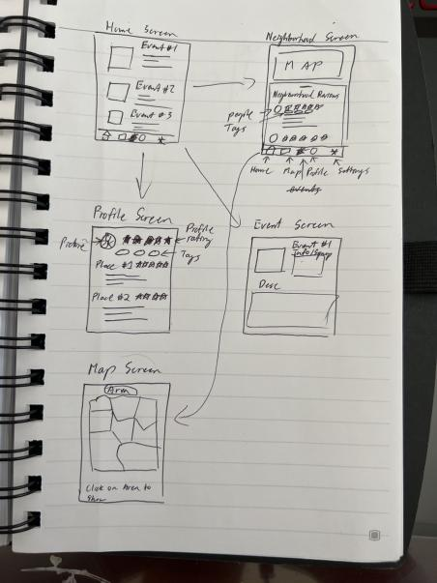

#### Description:

Potential Design 1 is inspired by Yelp, and allows people to review different districts in SF and also present potential events in that specific area. Users will be given tags based on district location (e.g. Sunset) and can leave reviews and/or post events in all districts

#### How it Will Work

Users are met with the Event’s page as the landing screen, which in hindsight doesn’t fit perfectly with our design. We would probably prefer to start with the Map Screen as the landing page. After clicking on a district, the user will be brought to the neighborhood screen where there will be another option to check the events in the specific neighborhood, with reviews separate in another tab/filtered.

#### Why it will work

Many of the people we interviewed look for ways to easily access up-to-date information on the different areas of SF. By simplifying the process to access information and allowing a review system, many more people are able to easily access advice with certain timestamps to show how the area was in the past or is now in the present.

#### Potential Limitations

* No Community around using the app
  + People don’t use the app
* The service will have a hard time in the early stages where all districts will have little to no reviews
* The design is limited in terms of peer-to-peer communication

#### Notes:

* Closeup Storyboard - Try a Broader Storyboard
* Have map Screen as home screen
* Have different Tabs in the neighborhood review
  + 1. Neighborhood review
  + 2. Event Tab

### Storyboard Design 2

Artist: Leilah Lui

Storyboard type: Big-Picture

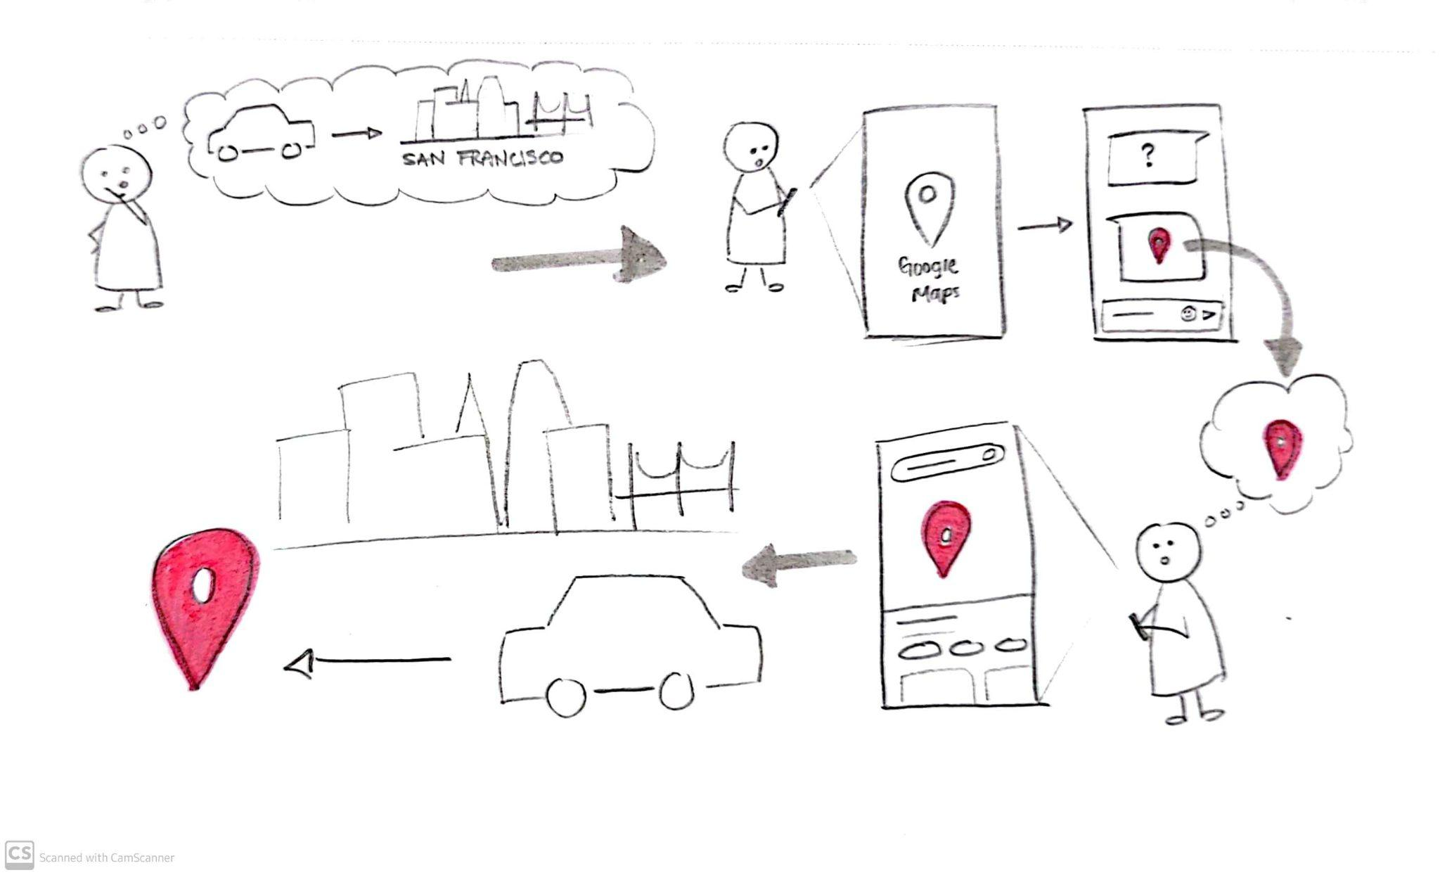

Storyboard type: Close-up

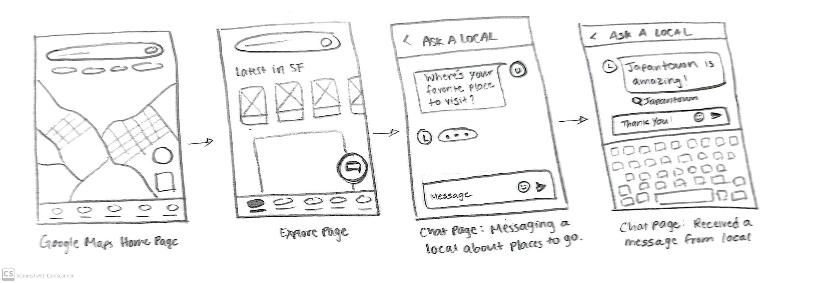

#### Description:

This potential design idea integrates into an existing mobile app, Google Maps. It’ll involve a chat feature where users can connect with and message locals of a specific area. Users can ask questions, gain a local’s perspective, and learn more about a certain location or place.

#### How it Will Work

The chat feature can be accessed from the Google Maps Explore page. This page already has listings of popular attractions, as well as posts and reviews of a region the user is currently zoomed in on the map. At the bottom right corner of the screen, there is a chat button where a user can “Ask a Local,” or message a local. From there the user can ask a local about anything! Users could ask a local about favorite restaurants, living conditions, local history, and more. Locals that respond can provide accurate information and travel suggestions to the user about their hometown/neighborhood/community.

#### Why it Will Work

Based on our research findings, we saw that people are happy to be a source of information regarding the areas they’re familiar with. Also, people experience often feel uncertain when they’re in an unfamiliar place and approach these situations with caution. However, people feel less uncertain when they feel more informed about a place. This chat feature will help people feel informed and, thus, more comfortable when they step outside of the comfort of their own community. Making the act of connecting with someone outside of one’s community a seamless and positive experience will facilitate interconnectivity among communities.

#### Potential Limitations

* Some information that will be shared between communities might be subjective and based on personal experience.
* The feature will be driven by Google Map users. If users don’t participate in or use this feature often, the feature will lose its main purpose.
* Users may not take this chat feature seriously and intentionally share inaccurate or inappropriate information.
* Some users might be concerned about the idea of messaging someone they don’t know.

### Storyboard Design 3:

Artist: Tyler Fulinara

Storyboard type: Close-up

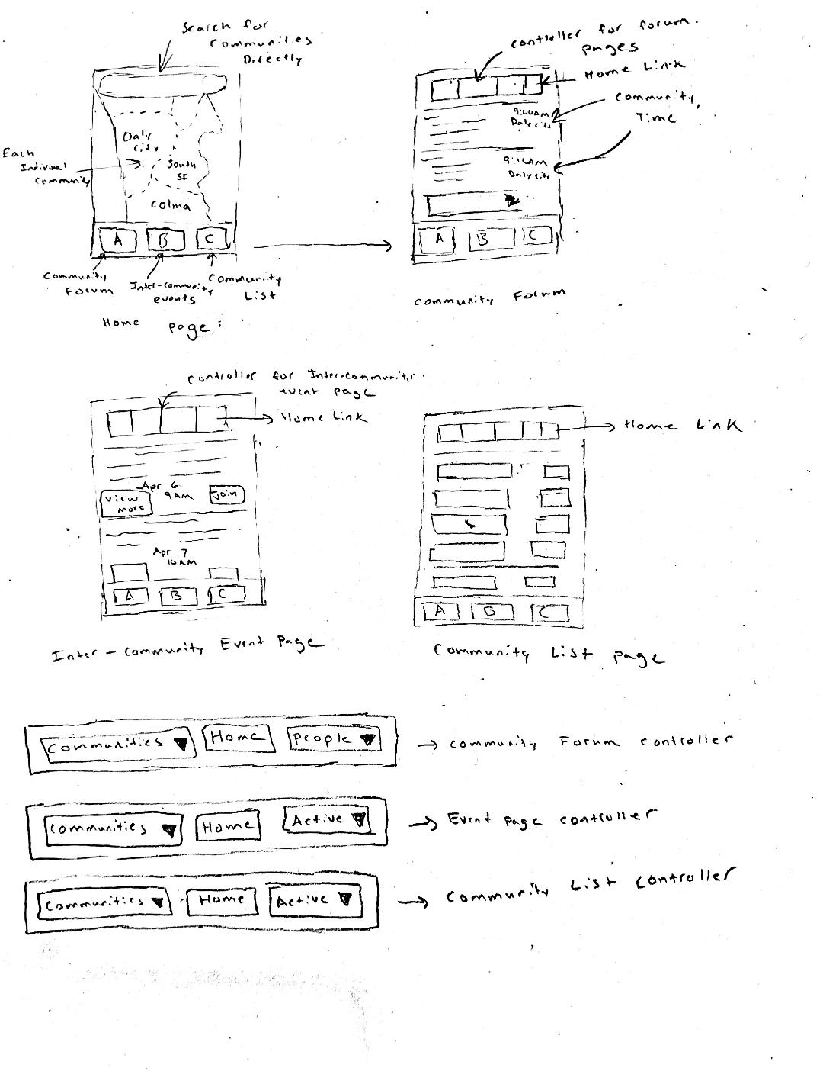

#### Description:

This potential design uses the three key ideas of encouraging interconnectivity, representing identity, and building a place to engage with others.

This integrates the idea that interconnectivity can be done through different events that are shown. We don’t want our platform to be a place where you advertise events, however, through design, we want to strike a balance of activities that people can join or post. This idea will push the idea of trying to build a community for all the different communities and give them a place where they can come together.

The second idea is pushing the idea of being able to provide accurate and accessible information. This is done through the community list. We will push the idea of giving each community a place where they fairly showcase their community. This is done by showing the different experiences and perspectives of the locals. This is mainly a place where the community’s identity is controlled by its community members and is a platform where they can define their own identity and showcase their identity to others outside of it.

The third idea I used is the key idea of providing a space to connect to members of the community. A lot of people we interviewed said the best way to understand a community is through its people. We want to be able to set up a platform that allows for this. One idea we have is to provide a way for people to build connections. This can be done in many different ways, however, the one I thought of is building a forum. This will cause a lot of possible backlashes, so further down the design process we want to check what exactly is being posted and who is posting.

#### Structure / Limitations

* Community Forum Page
  + Able to connect with members in your own community
  + Able to see and connect with events and people in other communities
  + Limits
    - Who gets to be in the community
    - Impact of people trying to misuse the system
* Event Page
  + Able to join events in all communities
  + Able to start up events with restrictions/limitations
  + Limits
    - Who has access to start up events
    - Will it leads to the app just being an advertising platform
* Community List Page
  + Able to view different communicates and pages that describe how that community
  + Able to see different communities in places that you are unfamiliar with
  + Limits
    - If the community gets pushed toward a negative light
    - Instead of showing the positive sides of a community, it solely focuses on the negative aspects.

# Conclusion:

The core problem that we are aiming to solve is to be able to bridge the gap between different communities in order to build a connection between different communities. Solving this problem will allow for interconnectivity among communities, which facilitates social interaction and accurate representation of communities. If this problem were to persist, it would lead to the misrepresentation of communities and mental issues due to the lack of social interaction. In order to learn more, we interviewed 6 different people trying to understand different perspectives on how people viewed communities and their identity from both inside and outside of a community. From the interviews we had, we learned that we want to focus on the solution of building a platform that will bridge the gap between San Francisco’s diverse set of neighborhoods and communities, thus encouraging socialization and discouraging isolation. In our findings, we saw 4 high-level themes: resources, safety, culture, and communities that will allow us to be able to build the platform with these ideas in mind. This leads to the 4 key ideas that we want to focus on in our design: connecting diverse together incorporating inter-connectivity, providing accurate and accessible representations of communities, providing a platform for members of diverse communities to connect, and showcasing the positive aspects of a certain region or community. This will be a platform that will have an impact on bridging the gap between a diversity of communities and correctly representing them the way the community wants.